**Week of May 28- June 03**

This report covers all the tweets sent between May 27 – June 02 that mentioned “coreystewartva”.

##### How many are retweets?  
   
 table(VA.tweetdf$isRetweet)

##   
## FALSE TRUE   
## 466 634

The conversation was dominated by retweets, accounting for 634 out of 1100, or 57.7%, of the total tweets.

**Top Tweets using the “coreystewartva”**

The following is an output of all the top 6 tweets with the most favorites and the most retweets in the tweets collection.

. A screenshot of the tweets that have both highest favorites and retweets are below for visualization.

**list of top 6 favorited retweet by CoreyStewartVA**

text  
## 1 Every criminal illegal alien should be deported and replaced with the politicians who declare their jurisdictions S… https://t.co/IYarDhEHke  
## 2 I met an awesome supporter at our Rally to Defeat MS-13 in Fairfax! A Caps fan too! Go Caps!!\n\n#ALLCAPS\n\n#VASen https://t.co/IV8NPB1zVK  
## 3 Building the wall is the right thing to do for families on both sides of the border.\n\n#BuildTheWall \n#RuleofLaw https://t.co/4l2f98vdK1  
## 4 Congrats to our new 5th District Congressional Candidate @Denver4VA! \n\nWe look forward to campaigning with you to… https://t.co/aD8TgnkLMG  
## 5 This is what happens when you elect Republicans who don’t have a backbone, who don’t stand up for anything. Most of… https://t.co/Cg2POnRCG1  
## 6 Just another indication of political correctness gone rampant. We cannot let the radical left erase our history.… https://t.co/HzkVZT9h7L  
## favoriteCount created screenName  
## 1 103 2018-06-03 15:48:30 CoreyStewartVA  
## 2 83 2018-06-02 22:04:44 CoreyStewartVA  
## 3 77 2018-05-29 18:38:39 CoreyStewartVA  
## 4 61 2018-06-03 15:55:04 CoreyStewartVA  
## 5 61 2018-06-01 14:13:44 CoreyStewartVA

**other than from coreystewart's account, most favorited**

## text  
## 1 Senior Virginia Trump staffer Mike Rubino explains why Trump 2016 fired @CoreyStewartVA and why Trump 2020 is not s… https://t.co/GJ4gn3SluP  
## 2 So Corey, you’re calling for imprisonment of politicians for a policy decision they made?\n\nHave you lost it so far… https://t.co/MmG7m63jsG  
## 3 This rally at the Fairfax county Jail was rained on and the exact moment @CoreyStewartVA mentioned God and rain- th… https://t.co/qSZbkoExEt  
## 4 Dad must be so proud..... https://t.co/fpi8r24e2U  
## 5 @GaPeachMeg_ @BridgetKF30 @maryann_penza @Nov2018election @NJ_Optimist @MagaApplePie @HDowning113 @TheGunGuy85… https://t.co/ypwKhyFCwR  
## 6 @Jason_Lehr @BridgetKF30 @GaPeachMeg_ @maryann_penza @Nov2018election @NJ_Optimist @MagaApplePie @HDowning113… https://t.co/T2QzU3j1za  
## favoriteCount created screenName  
## 1 114 2018-05-31 20:23:22 TrumpStudents  
## 2 105 2018-06-03 15:56:33 DavidIRamadan  
## 3 38 2018-06-02 20:13:07 eugenedelgaudio  
## 4 36 2018-05-31 22:33:09 Dennis17Viper  
## 5 27 2018-05-28 22:59:44 JMAN23SD  
## 6 25 2018-05-29 00:05:04 FoxatFives

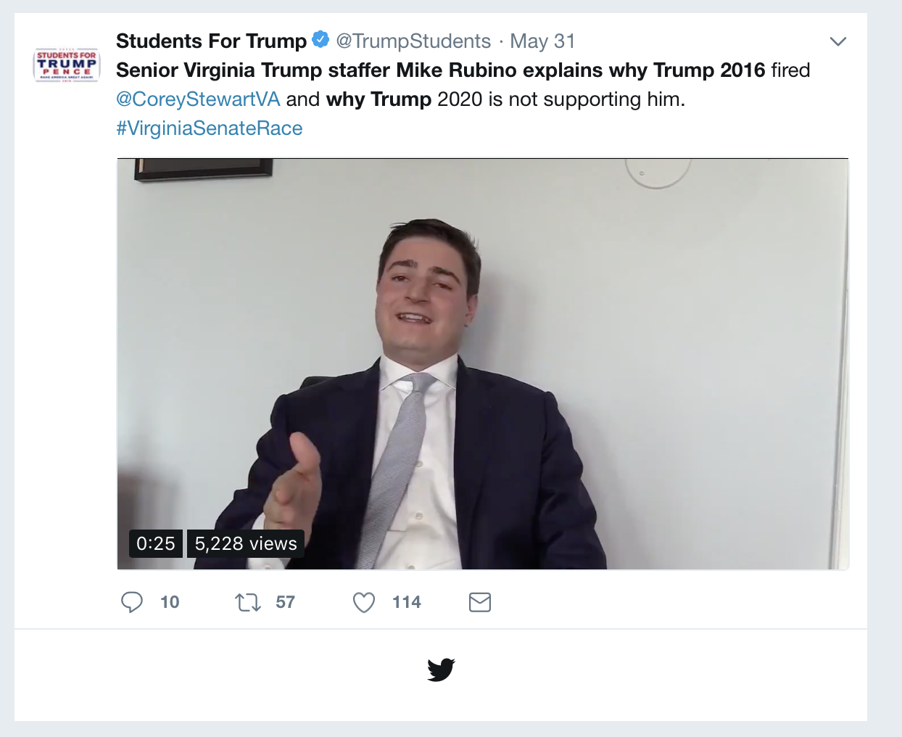

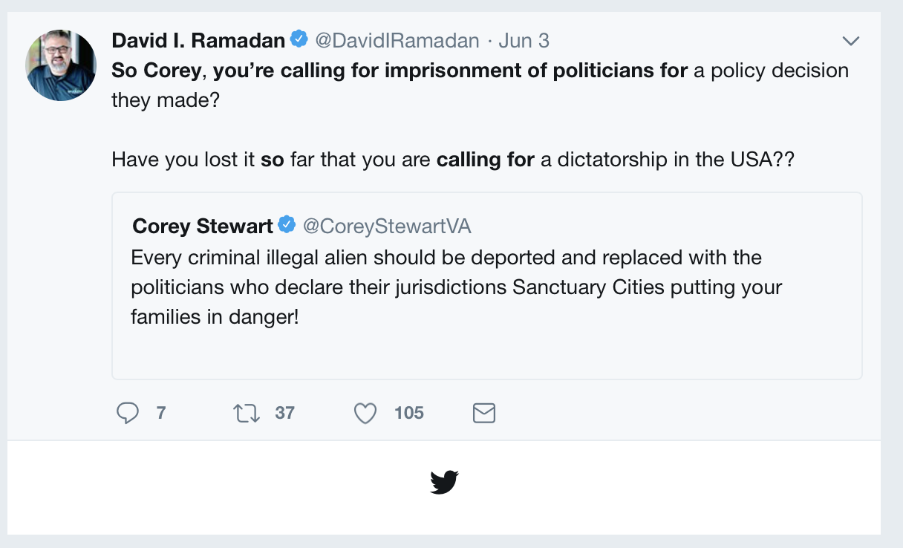

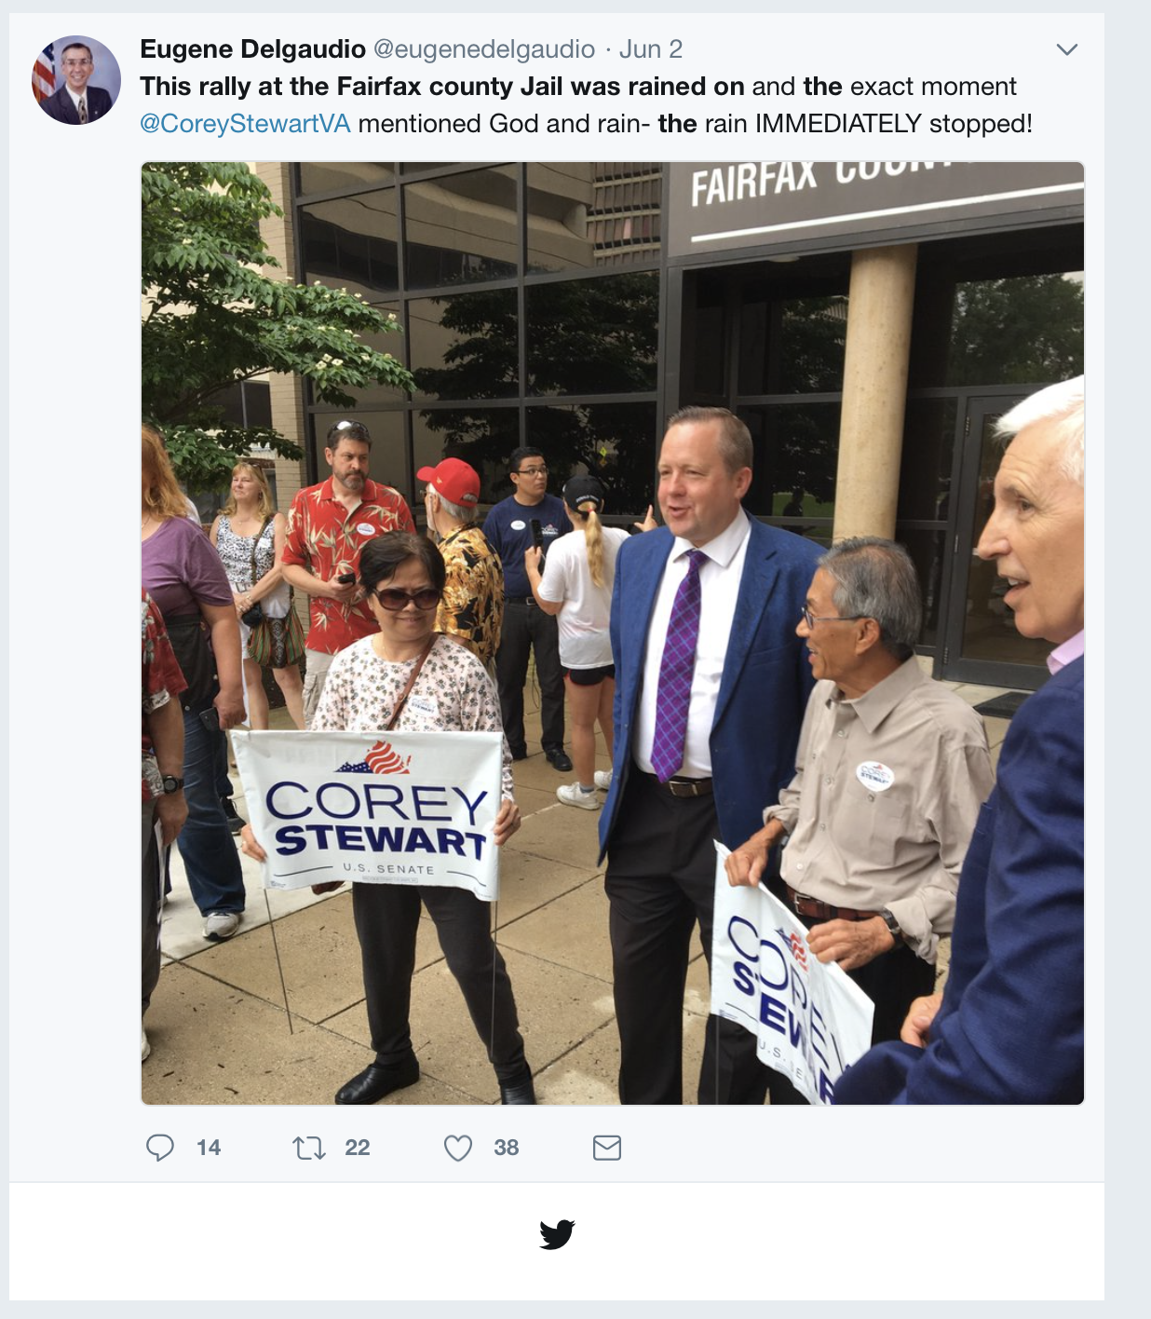

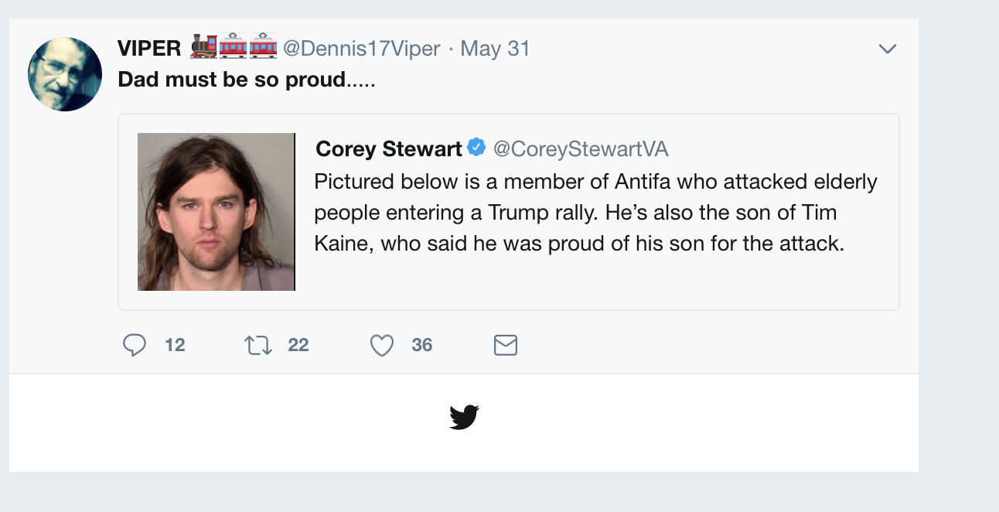

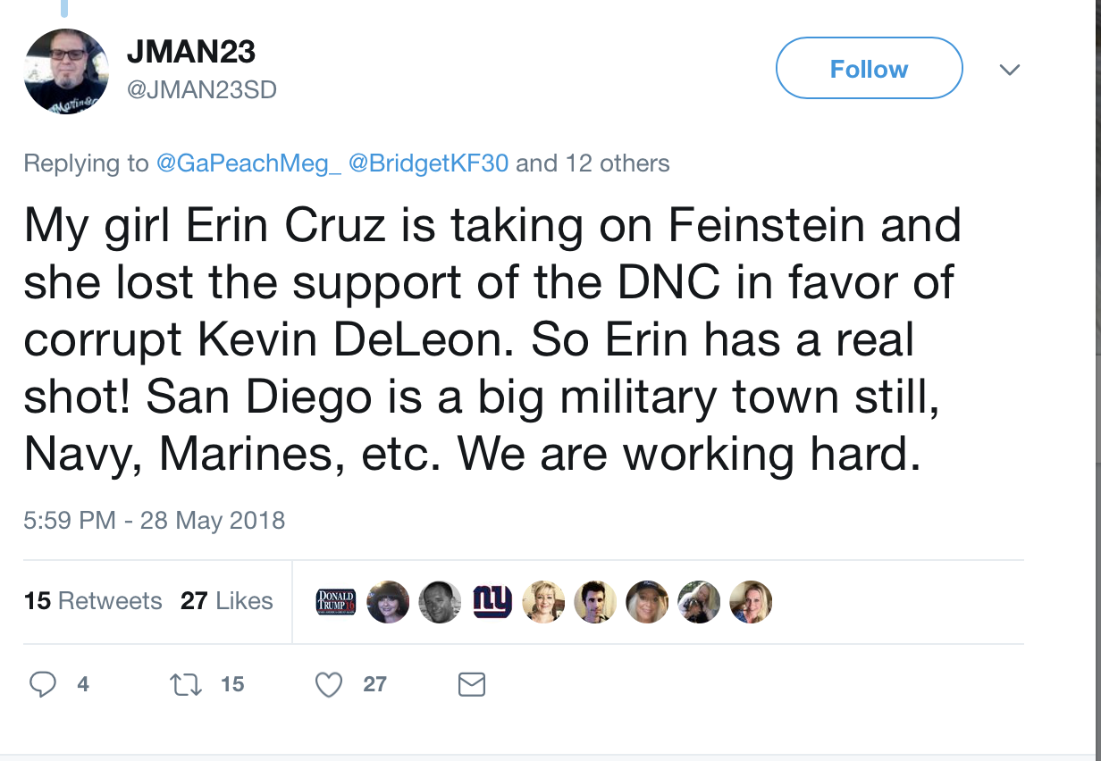

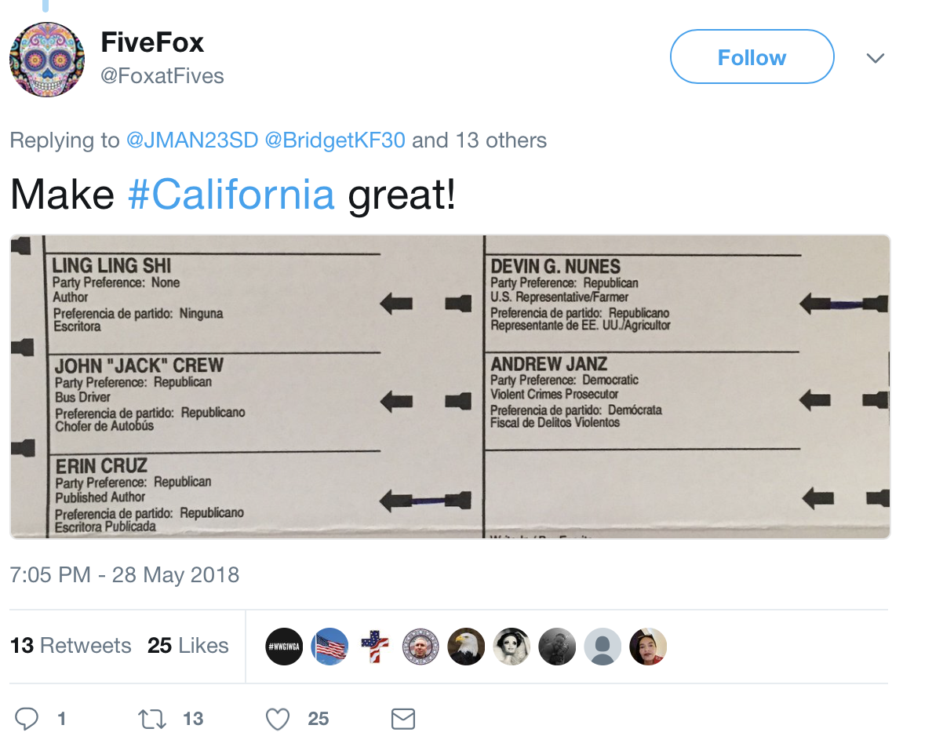

**top 6 retweeted tweet By coreystewartva**

## text  
## 1 Every criminal illegal alien should be deported and replaced with the politicians who declare their jurisdictions S… https://t.co/IYarDhEHke  
## 2 I met an awesome supporter at our Rally to Defeat MS-13 in Fairfax! A Caps fan too! Go Caps!!\n\n#ALLCAPS\n\n#VASen https://t.co/IV8NPB1zVK  
## 3 This is what happens when you elect Republicans who don’t have a backbone, who don’t stand up for anything. Most of… https://t.co/Cg2POnRCG1  
## 4 Building the wall is the right thing to do for families on both sides of the border.\n\n#BuildTheWall \n#RuleofLaw https://t.co/4l2f98vdK1  
## 5 Congrats to our new 5th District Congressional Candidate @Denver4VA! \n\nWe look forward to campaigning with you to… https://t.co/aD8TgnkLMG  
## 6 RT @eugenedelgaudio: This rally at the Fairfax county Jail was rained on and the exact moment @CoreyStewartVA mentioned God and rain- the r…  
## retweetCount created screenName  
## 1 44 2018-06-03 15:48:30 CoreyStewartVA  
## 2 33 2018-06-02 22:04:44 CoreyStewartVA  
## 3 28 2018-06-01 14:13:44 CoreyStewartVA  
## 4 25 2018-05-29 18:38:39 CoreyStewartVA  
## 5 23 2018-06-03 15:55:04 CoreyStewartVA  
## 6 22 2018-06-03 15:58:04 CoreyStewartVA

# top 6 retweeted tweet Not including Corey

## text  
## 1 Senior Virginia Trump staffer Mike Rubino explains why Trump 2016 fired @CoreyStewartVA and why Trump 2020 is not s… https://t.co/GJ4gn3SluP  
## 2 So Corey, you’re calling for imprisonment of politicians for a policy decision they made?\n\nHave you lost it so far… https://t.co/MmG7m63jsG  
## 3 This rally at the Fairfax county Jail was rained on and the exact moment @CoreyStewartVA mentioned God and rain- th… https://t.co/qSZbkoExEt  
## 4 Dad must be so proud..... https://t.co/fpi8r24e2U  
## 5 @GaPeachMeg_ @BridgetKF30 @maryann_penza @Nov2018election @NJ_Optimist @MagaApplePie @HDowning113 @TheGunGuy85… https://t.co/ypwKhyFCwR  
## 6 @BridgetKF30 @TheGunGuy85 @Nov2018election @MagaApplePie @SykesforSenate @RealErinCruz @CoreyStewartVA @kelliwardaz… https://t.co/00LDTYXaOO  
## retweetCount created screenName  
## 1 57 2018-05-31 20:23:22 TrumpStudents  
## 2 37 2018-06-03 15:56:33 DavidIRamadan  
## 3 22 2018-06-02 20:13:07 eugenedelgaudio  
## 4 22 2018-05-31 22:33:09 Dennis17Viper  
## 5 15 2018-05-28 22:59:44 JMAN23SD  
## 6 14 2018-05-29 00:33:31 HDowning113

### Top ten retweets overall

In this case, there were tweets that were created before the week that were still being shared on Twitter and accumulating retweets.

## text  
## 1 RT @cs0058sc: \xed\xa0\xbd\xed\xb4\xb5\xed\xa0\xbd\xed\xb4\xb4VIRGINIA &amp; UTAH PATRIOTS\xed\xa0\xbd\xed\xb4\xb5\xed\xa0\xbd\xed\xb4\xb4\n\nYesterday, Mike Kennedy upset Romney forcing a primary for the Senate seat. Pls help get the wo…  
## 2 RT @Nov2018election: Support These Conservative Patriots In https://t.co/YKNinEfqQi In Your State Primary\xed\xa0\xbc\xed\xb7\xba\xed\xa0\xbc\xed\xb7\xb8 @SykesforSenate @NewDayForNJ @D…  
## 3 RT @Nov2018election: (1) Support These Candidates In Nov Vote In Your State Primary #KAG #FreedomIsntFree @DannyTarkanian @SaarioBrandon @A…  
## 4 RT @CoreyStewartVA: Pictured below is a member of Antifa who attacked elderly people entering a Trump rally. He’s also the son of Tim Kaine…  
## 5 RT @cs0058sc: \xed\xa0\xbd\xed\xb4\xb5\xed\xa0\xbd\xed\xb4\xb4Calling all MAGA PATRIOTS\xed\xa0\xbd\xed\xb4\xb5\xed\xa0\xbd\xed\xb4\xb4\n\nOur Candidates need our help.\n\xed\xa0\xbd\xed\xb9\x8fRegister\n\xed\xa0\xbd\xed\xb9\x8fFollow\n\xed\xa0\xbd\xed\xb9\x8fRT\n\xed\xa0\xbd\xed\xb9\x8fDonate\n\xed\xa0\xbd\xed\xb9\x8fVolunteer\n\xed\xa0\xbd\xed\xb4\xb4Vote\n@CoreyStewartVA @…  
## 6 RT @Deplorables4US: Please welcome 5 new candidates to the Deplorable Congress Family! \n\n• .@CoreyStewartVA \n• .@kelliwardaz \n• .@DannyTark…  
## 7 RT @NewDayForNJ: @ramejame2 @Nov2018election @VFL2013 @SykesforSenate @RealErinCruz @CoreyStewartVA @kelliwardaz @JohnJamesMI Thank you @ra…  
## 8 RT @TrumpStudents: Senior Virginia Trump staffer Mike Rubino explains why Trump 2016 fired @CoreyStewartVA and why Trump 2020 is not suppor…  
## 9 Senior Virginia Trump staffer Mike Rubino explains why Trump 2016 fired @CoreyStewartVA and why Trump 2020 is not s… https://t.co/GJ4gn3SluP  
## 10 Every criminal illegal alien should be deported and replaced with the politicians who declare their jurisdictions S… https://t.co/IYarDhEHke  
## retweetCount created screenName isRetweet  
## 1 305 2018-06-02 23:51:09 FlagofFreedom4 TRUE  
## 2 267 2018-06-03 12:41:00 2018MAGAMidTrmT TRUE  
## 3 244 2018-05-30 15:49:30 AlbertBruno2017 TRUE  
## 4 186 2018-06-03 18:57:28 SiRegan1 TRUE  
## 5 158 2018-06-01 23:09:42 SandysOpinion TRUE  
## 6 82 2018-06-03 03:04:01 karmasenz TRUE  
## 7 59 2018-06-02 09:18:43 HDowning113 TRUE  
## 8 57 2018-06-03 17:29:58 MacStoddard TRUE  
## 9 57 2018-05-31 20:23:22 TrumpStudents FALSE  
## 10 44 2018-06-03 15:48:30 CoreyStewartVA FALSE

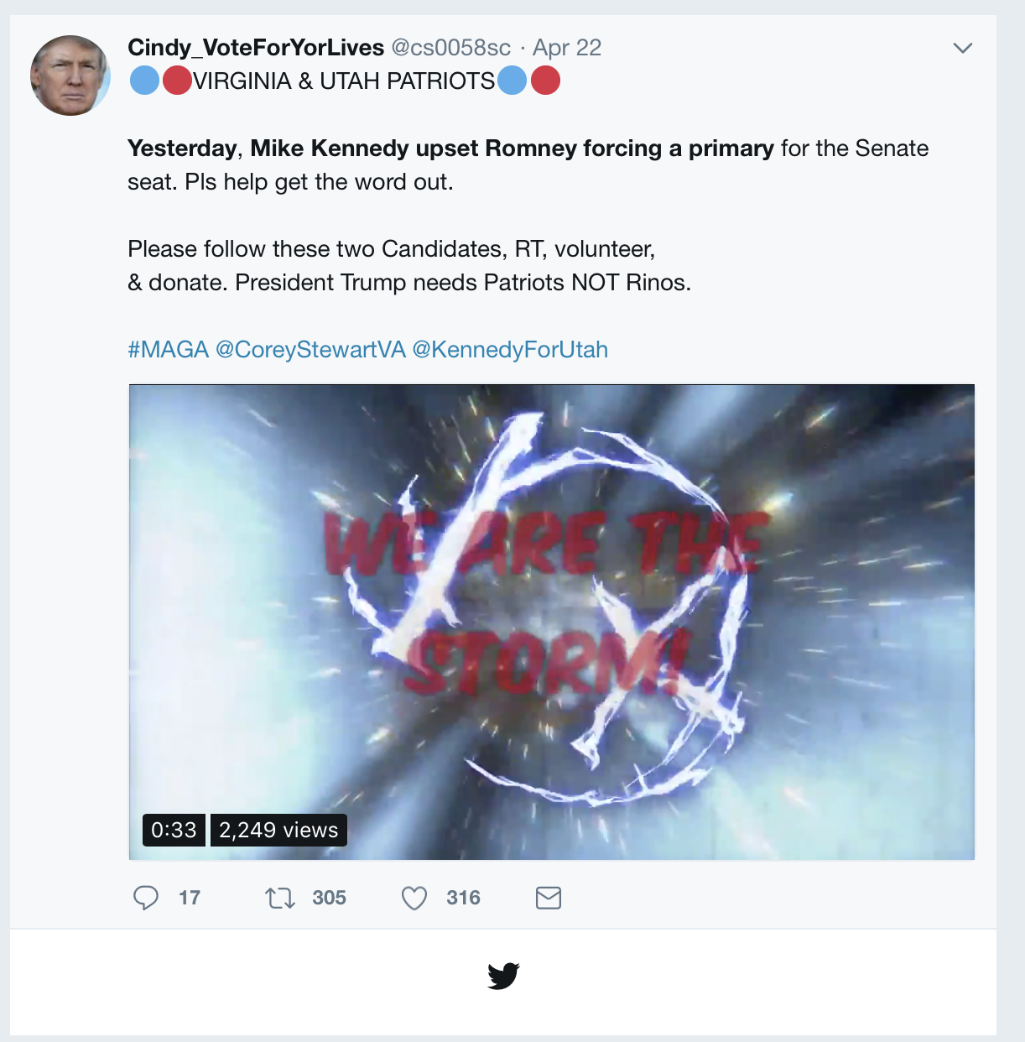

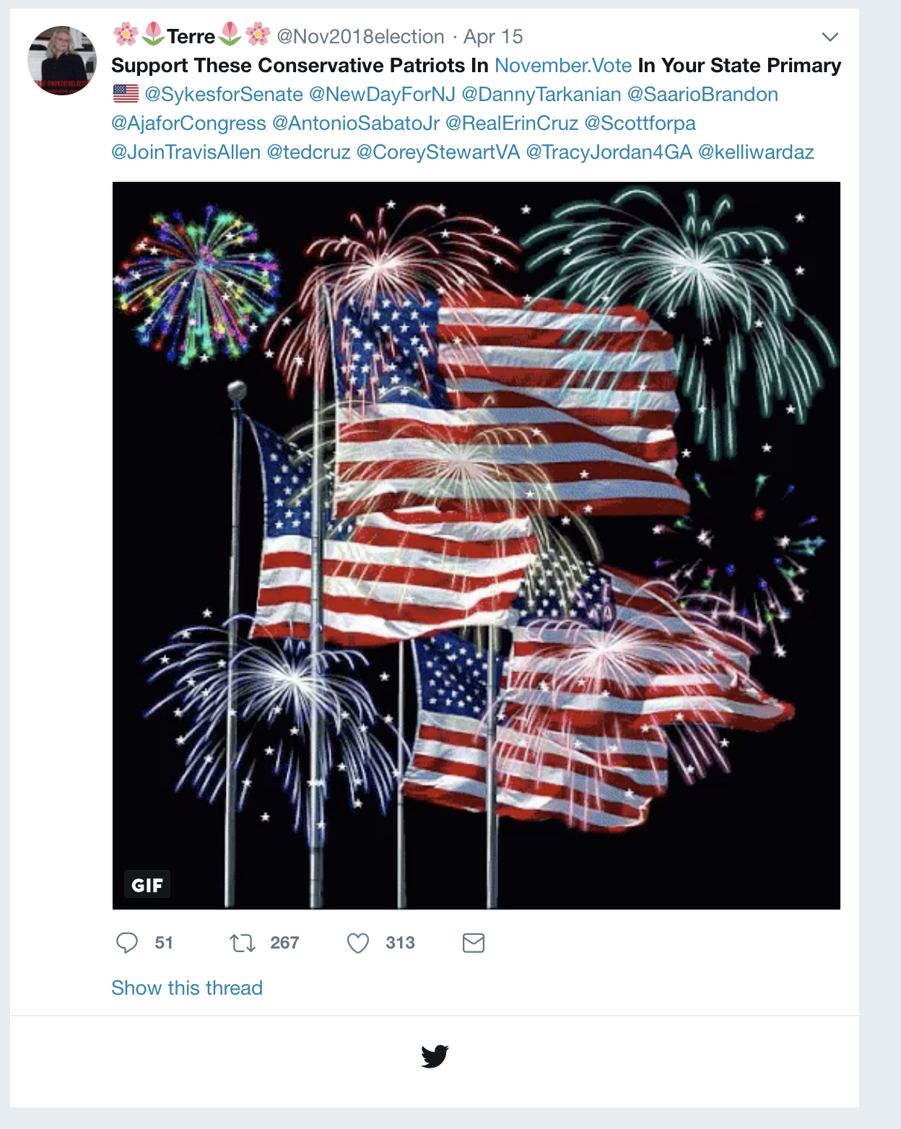

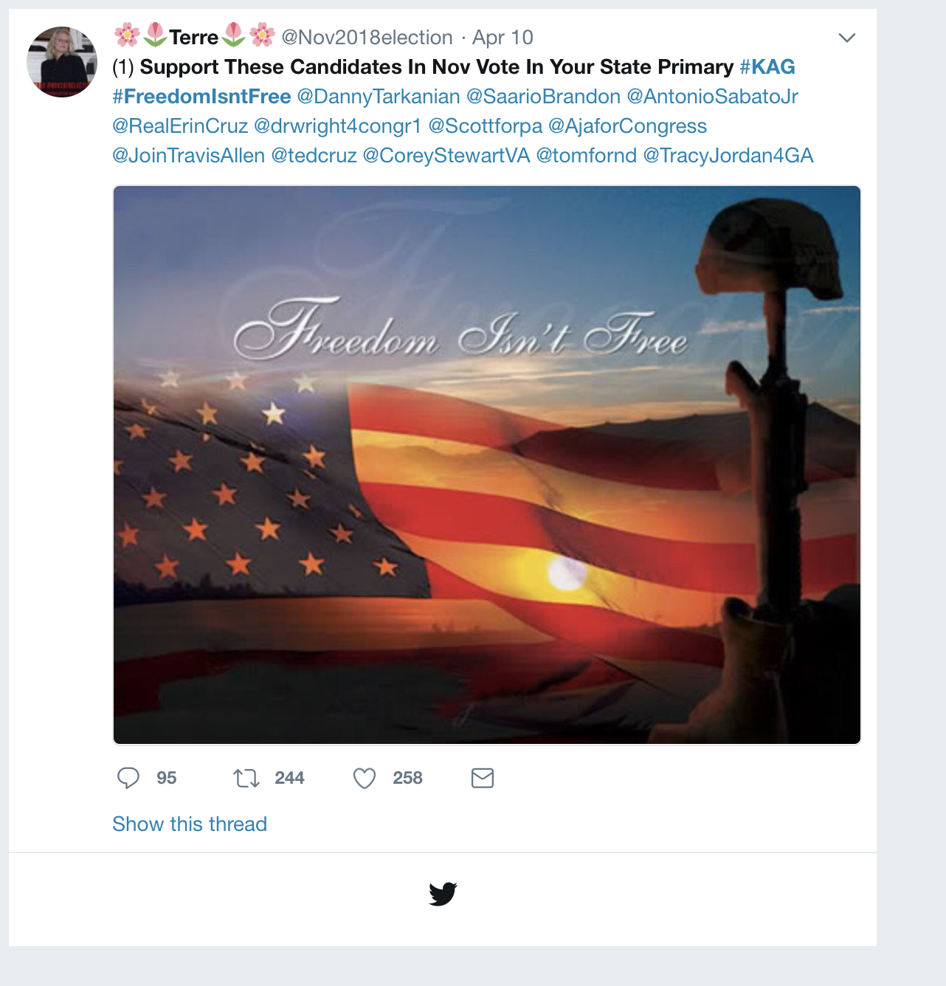

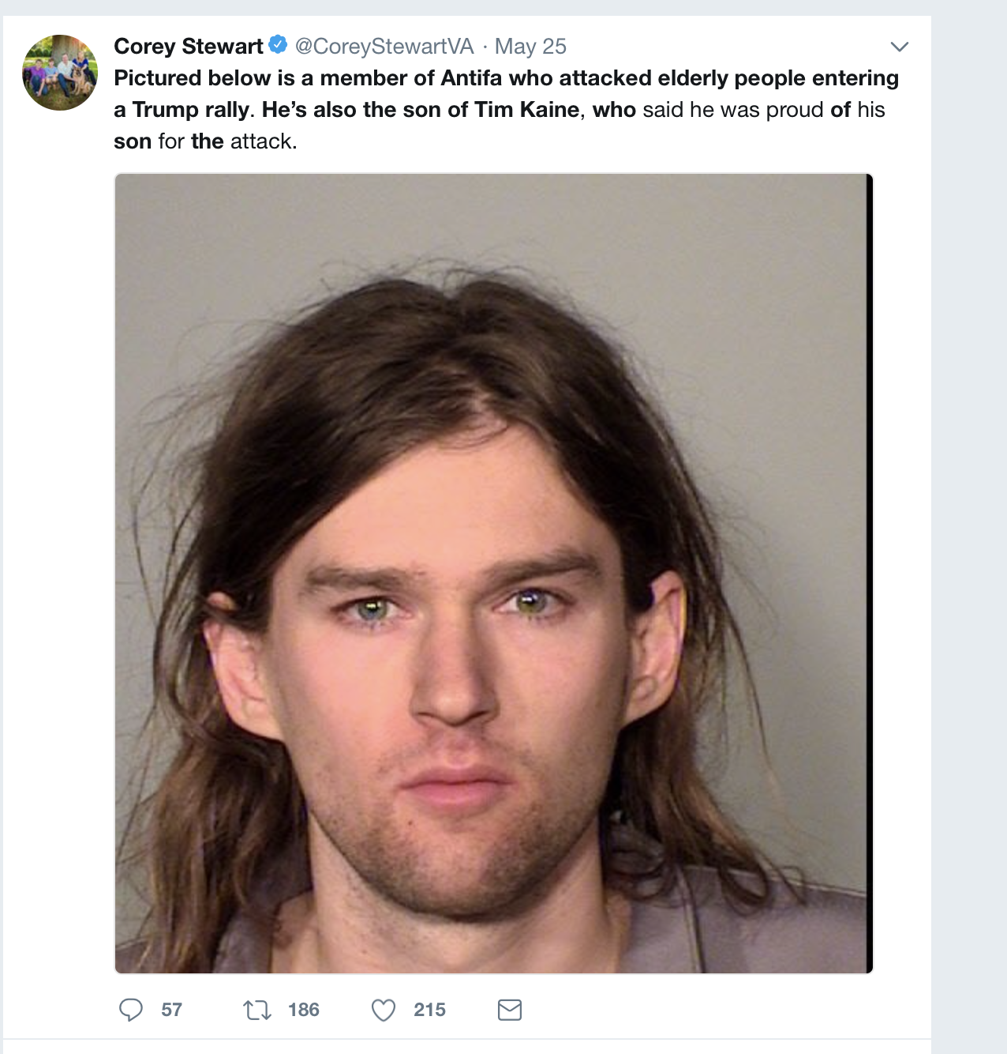

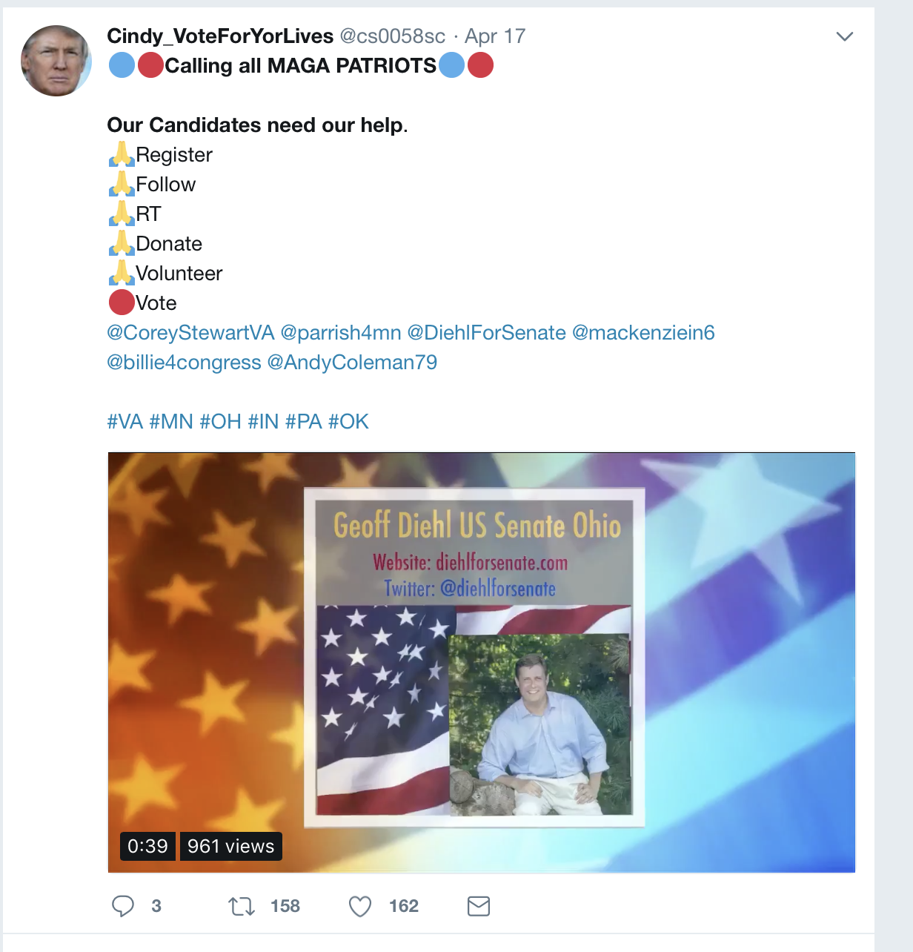

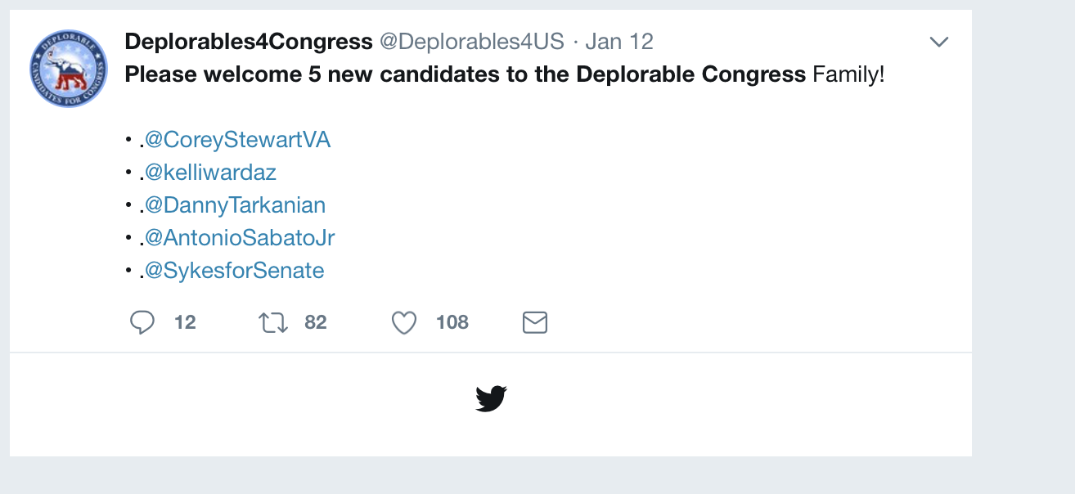

**Accounts dominating the Conversation**

These twitter handles have aggregated the most retweets out of all the tweets that they have sent out.

**accounts that have the most total Retweets**

## screenName x  
## 39 CoreyStewartVA 176  
## 157 Nov2018election 75  
## 210 TrumpStudents 57  
## 82 HDowning113 45  
## 47 DavidIRamadan 37  
## 74 GaPeachMeg_ 34

**Most Active Accounts (including Retweets)**

These twitter handles have sent out the most tweets during the week (Including tweets)

## Var1 Freq  
## 189 HDowning113 64  
## 367 Nov2018election 56  
## 492 TheGunGuy85 34  
## 73 BridgetKF30 30  
## 358 NewDayForNJ 24  
## 153 eugenedelgaudio 23

**Most Active Accounts**

These twitter handles have sent out the most original tweets during the week.

## Var1 Freq  
## 64 eugenedelgaudio 20  
## 135 maryann_penza 16  
## 157 Nov2018election 15  
## 29 BridgetKF30 14  
## 90 IlIlIlIlIl7 13  
## 74 GaPeachMeg_ 12

**VISUALIZATION**

#WORDCLOUD of most common used words

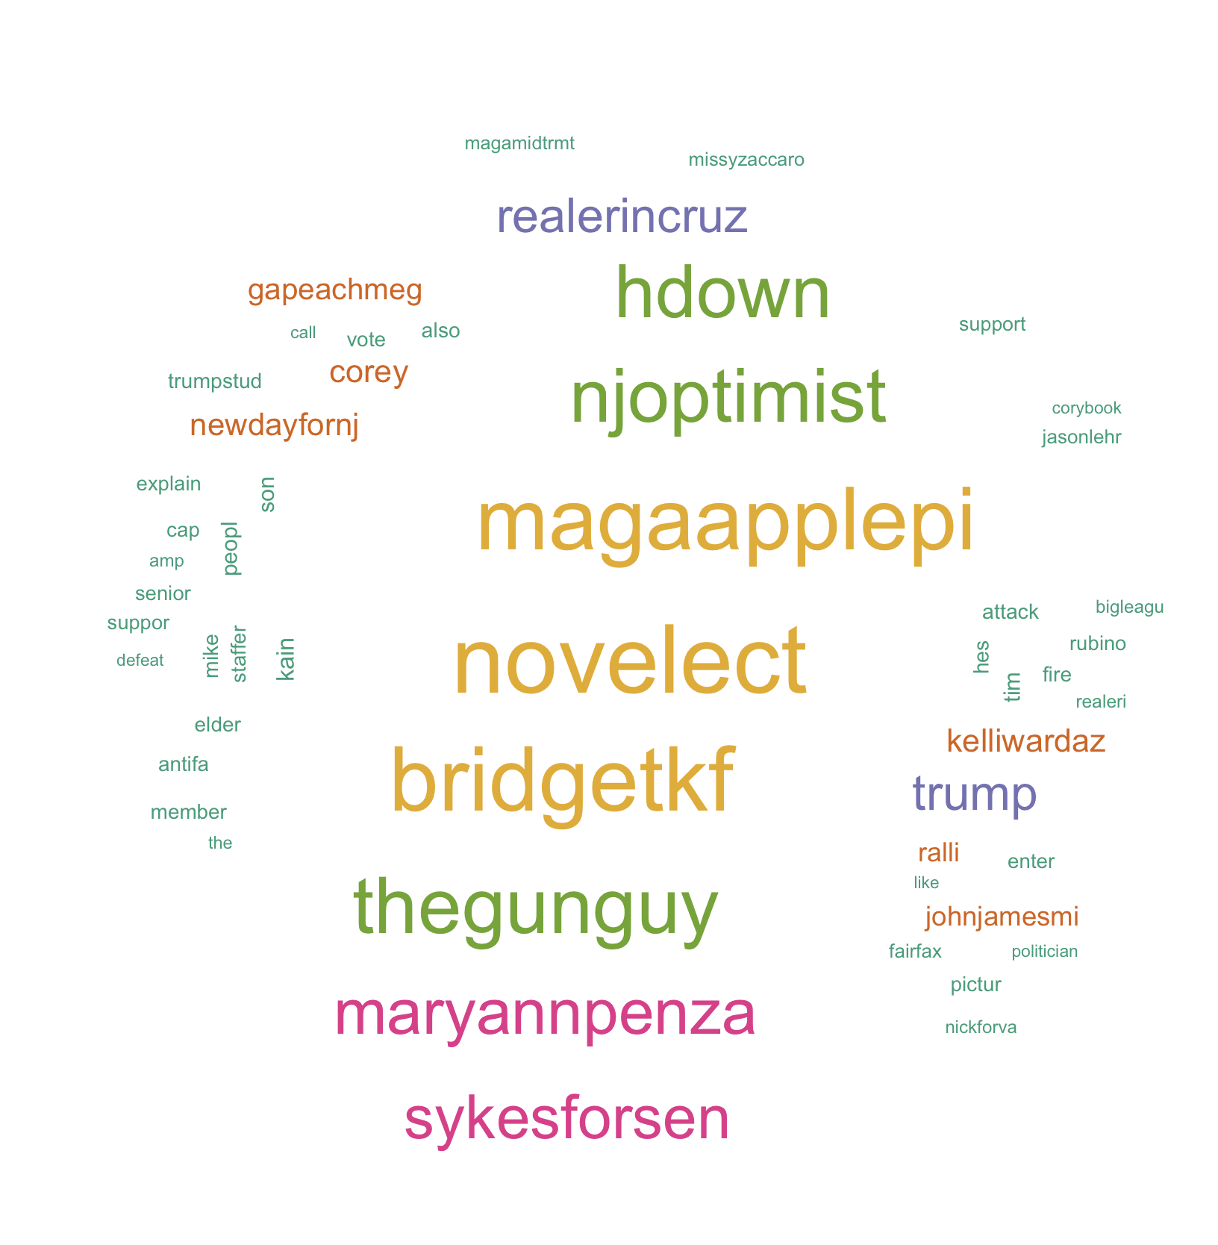

# List of The Top Ten Frequently used Words

## word freq  
## novelect novelect 497  
## bridgetkf bridgetkf 463  
## magaapplepi magaapplepi 449  
## thegunguy thegunguy 396  
## njoptimist njoptimist 376  
## hdown hdown 369  
## maryannpenza maryannpenza 310  
## sykesforsen sykesforsen 293  
## trump trump 222  
## realerincruz realerincruz 216

# Plot of Words that Appear at least 50 times

##   
## Attaching package: 'ggplot2'

## The following object is masked from 'package:NLP':  
##   
## annotate

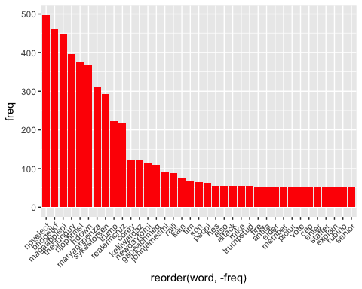

## Words Associated with

To find out what words are associated with the candidates, I use a function called FindAssocs() on the dataset. For any given word, findAssocs() calculates its correlation with every other word in the dataset. Scores range from 0 to 1. A score of 1 means that two words always appear together, while a score of 0 means that they never appear together.

# which words are associated with "Corey Stewart"  
   
 findAssocs(tdm,"coreystewartva", 0.1)

## $coreystewartva  
## dee georg prais give public   
## 0.82 0.82 0.82 0.75 0.75   
## staff week lincoln rock emh   
## 0.75 0.75 0.74 0.74 0.68   
## open volunt amp campaign confer   
## 0.60 0.60 0.57 0.55 0.47   
## oppos press much prepar team   
## 0.47 0.47 0.38 0.33 0.33   
## washingtonle big school base seem   
## 0.27 0.25 0.23 0.23 0.23   
## fall high certain chang name   
## 0.23 0.23 0.23 0.22 0.22   
## love gweinschenk arlington   
## 0.19 0.16 0.13

findAssocs(tdm,"nickforva", 0.1)

## $nickforva  
## rais craigcarp tax analysi   
## 0.52 0.47 0.45 0.44   
## icymi wcve fact correct   
## 0.44 0.44 0.43 0.41   
## matter mult show addit   
## 0.41 0.40 0.38 0.37   
## full iansam repeal weve   
## 0.37 0.37 0.37 0.37   
## medicaid creat kwilli wmaldc   
## 0.35 0.33 0.33 0.33   
## dependen our larryoconnor parentwayn   
## 0.33 0.31 0.29 0.28   
## after liberti lisajon expans   
## 0.28 0.28 0.28 0.28   
## multipl claim want total   
## 0.28 0.27 0.24 0.24   
## did deba univers cockburn   
## 0.24 0.23 0.23 0.23   
## crank exit negat ryanafourni   
## 0.23 0.23 0.23 0.23   
## checker watch kylekashuv larrysabato   
## 0.23 0.19 0.19 0.19   
## william time race grammar   
## 0.18 0.17 0.16 0.16   
## judg won princ prick   
## 0.16 0.16 0.16 0.16   
## swampmonst gjtiii nicki protect   
## 0.16 0.16 0.16 0.16   
## stumpfortrump themrsporch gilesgop incorrect   
## 0.16 0.16 0.16 0.16   
## smdinner armi fellow had   
## 0.16 0.16 0.16 0.16   
## pleasur veteran universi johnrlinton   
## 0.16 0.16 0.16 0.16   
## trumptrain wise delrbel jillhvogel   
## 0.16 0.16 0.16 0.16   
## rumor barbaracomstock loudouninspir meemi   
## 0.16 0.16 0.16 0.16   
## repcomstock disagre che prepar   
## 0.16 0.16 0.16 0.16   
## team barrel minnesotan vahousegop   
## 0.16 0.16 0.16 0.16   
## appear establish lloyd mark   
## 0.16 0.16 0.16 0.16   
## misogynist vulgar run like   
## 0.16 0.16 0.13 0.12   
## say ballot virginiamagakag base   
## 0.12 0.11 0.11 0.11   
## alreadi governor bottom crash   
## 0.11 0.11 0.11 0.11   
## border defend seem consid   
## 0.11 0.11 0.11 0.11   
## fall come nomin stori   
## 0.11 0.11 0.11 0.11   
## certain   
## 0.11

findAssocs(tdm,"ewjacksonsr",0.1 )

## $ewjacksonsr  
## nickfreitasva repubsatodu handicap sham   
## 0.63 0.63 0.45 0.45   
## sinc ounc recruit rpv   
## 0.45 0.45 0.45 0.45   
## barbaracomstock loudouninspir meemi repcomstock   
## 0.45 0.45 0.45 0.45   
## but integr shakhil inform   
## 0.31 0.31 0.26 0.26   
## tweetrhandl someon pay whi   
## 0.22 0.22 0.20 0.18   
## make public wait still   
## 0.16 0.16 0.16 0.15   
## pleas volunt campaign for   
## 0.14 0.13 0.12 0.12

**Coreystewartva tweets per day**

